Guidance & templates on the monitoring of the smart village design & implementation process

- GUIDANCE
  - Purpose of the tool
This short guidance serves to help to monitor the (smart) village strategy development & implementation process. This method has been used for the purpose of monitoring, learning and drawing overall lessons about the process of smart village strategy development and implementation process in the Smart Rural 21 project. It aims to help rural communities to understand and help to overcome bottlenecks. It is important that the tool generally does not intend to evaluate the strategy implementation itself – that is context-specific and depends on the intervention logic (objectives, actions, outputs, results, etc.) planned in the smart village strategies. The focus here is on the process of design & implementation, with emphasis on stakeholder engagement.
  - Key components
- The monitoring process concerns the review of the achievement of the key milestones in the smart village strategy development & implementation process (in line with the key stages of the Smart Village Roadmap).
- Stakeholder engagement/ participatory approach is a key aspect of Smart Villages and therefore, these are crosscutting at all stages of the strategy design and implementation process.
- For the purpose of the monitoring 10 key milestones have been defined as follows:
- Getting started
- Mapping context & stakeholders
- Engaging stakeholders
- Designing strategy
- Smart Village Strategy
- Planning actions
- Finding solutions
- Generating actins
- Financing
- Management & monitoring
- For each milestone there are specific ‘monitoring criteria’ defined. Questions are formulated to help assess each criterion and determine how the village performed at that stage: what difficulties it faced; what the stronger/ weaker aspects have been; what positive experiences there are, etc.
- The monitoring tool can be used by authorities or consultants who have the role to carry out the monitoring or assessment of smart village strategy processes, understand the possibilities and level of community engagement. It can also be used by rural communities directly as a ‘self-assessment’ tool, to help improving the process of strategy design and implementation in the community.
- It is important that, in case the tool is used by “external” stakeholders (i.e. not as a self-assessment tool by the village representatives), the process should be carried out in close cooperation with the village representatives. For instance, the “monitoring expert” might complete first the template independently from the village, and then discuss the findings with the village representatives. It is also possible that the village representative(s) complete the report independently from the “monitoring expert”, and then the two assessments (that of the expert and that of the village representatives) are compared and discussed (with focus on the diverging opinions). Please note however, that this process should not be burdening for the village representatives: Village representatives need to be involved only as much as they are interested. The “monitoring expert” should lead/ guide the process, and ultimately help to form an independent opinion.
- It is advisable to identify some (independent) local stakeholders who could be interviewed beyond those in the village who have been responsible for designing and/or implementing the strategy. Identify at least 2 to 5 local interviewees. If you are an external monitoring expert, you can get in touch with people and arrange interviews:
- You can ask the village representatives (leads) when contacting them in the context of explaining the monitoring process to recommend 3 to 10 contact persons who were involved in some ways in the strategy development process (consulted, engaged, etc.). These people should be local inhabitants. You can select 2 to 5 interviewees among the suggested names.
- You might know some people already whom you could consult. You can suggest to /inform the main village representatives (leads) that you will prepare interviews with them.
- External perspective on the process is always useful and helps to carry out an unbiased assessment. It has to be realistic & objective – done as much as possible with the village representatives, but ultimately informed by the monitoring expert’s independent view. Use as much evidence as possible to support the arguments in the assessment.
- It is possible to divide the monitoring process into two stages (as it was done in the Smart Rural 21 project): i.e. first carry out the strategy design process monitoring and at a later stage the strategy implementation process monitoring.
  - Methodology and key steps for “monitoring experts”
- Familiarise yourself with the template, questions, etc. (It might look complex at first sight, but experts who worked on it reported that it is much simpler to use then it seems at first).
- If you are an external “monitoring expert”, discuss with the village representative(s) the purpose of the exercise (you can share this document to explain) and if & how far they would like to be involved in the process – make sure it is not a burden for them (it is also fine if they don’t want to be involved). Options to involve village representatives are:
- They could fill in the questionnaire briefly themselves (note that there is no need to very detailed and elaborated responses from them – the point is to have a basis of discussion/ reflection) and you can arrange a discussion with them for later to discuss how they saw the process and how you saw it.
- They might prefer not to fill in the questionnaire but to discuss with you your ‘assessment’. This means that you can share your views/ assessment with them and arrange a discussion to see what they think.
- They might prefer not to be involved at all.
- Prepare the interviews & arrange discussions with members of the community: Have (informal) discussions with the local people who might have relevant knowledge about the strategy. Interviews do not need to be excessive. The point is to get an impression on how and how far local people (other than those directly involved in preparing the strategy) have been aware and/or involved/engaged in the process of smart village strategy development. You can organise dedicated sessions (e.g. focus groups) to better understand how people feel about the smart village strategy & strategy implementation process and outcomes.
- Complete the monitoring template: Based on the information that you have – your own experience in working with the village (if applies), the feedback from/ discussion with village representatives (leads), local people interviewed – complete the monitoring template.
- Provide an overall score on a scale of 1 to 10 for each of the milestones. You do not necessarily need to score each criterion independently (this is optional also in the monitoring template), and the overall score is not necessarily constructed as the average of individual criteria scoring within that milestone (as the different criteria might have different weights in the assessment).
- Please note that not all / individual criteria need to be assessed ‘10’ to receive an overall milestone score of ‘10’. Some criteria may be substitutes (i.e. either/or) of each other (e.g. no prior comprehensive baseline analysis in place, but the village did it during the strategy development process – or vice versa). As another example, it might not be a ‘negative’ aspect if a village hasn’t had a flagship project prior to the strategy development but have clear ideas on what actions to take. This means that in an extreme case, it is possible to get a score of ‘1’ on some aspects but still have an overall score of ‘10’.
- Consider that villages might not be able to influence all criteria (i.e. low scoring is not necessarily a “weakness” of the village – it is rather an aspect to pay attention to/ improve later on). There might be external factors that influence whether the village is scoring high or low on a specific aspect (e.g. if the number of stakeholders that can be mobilised locally is limited – this is something that is hard to influence by the village in the short run – this needs to be explained in the assessment).
- When filling the ‘assessment / justification’ column of the template, consider the list of questions in Section 1.4 below. Please provide short/ concise and informative answers (to the questions that you consider relevant) – avoid generic statements - which will form the justification of your scoring. Short assessments/ justifications should be specific, factual and evidenced as much as possible (i.e. not just personal opinions). Answers should be ‘to the point’ (at the same time leading to meaningful overall conclusions).
- You can use the information provided in the (Smart) Village Strategy (and the descriptions in the relevant sections) to complete the template (e.g. stakeholder engagement events, etc.).

Example:
1. Getting started | 1.1. Local governance capacity | - No elected leaders in the village. The local village association takes a leading role, with few (2-3) key leading figures (including local volunteers, entrepreneurs, etc.) taking the lead in the process. | 7 | 8
 | 1.2 Leadership & vision | - Local interviews show that the village leaders are well respected and the vision they represent is known and shared by the members of the community | 10
 | 1.3 Local stakeholder capacity | - Local interviews show that people didn’t have much capacity / time or interest to get involved in the strategy development process. This has been mostly led by the few leading figures, with some input (opinions) from some members of the village association. | 5

  - Milestones, criteria, monitoring questions and scoring guidance
1.4.1 Strategy design milestones, criteria, indicative questions and scoring guidance
Milestone | Criteria | Indicative set of monitoring questions | Give a score of 10 if…
1. Getting started | 1.1. Local governance capacity | - Does your community have leading figures or organisations that can lead the smart village development/ manage and monitor the smart village process?  - How do leading figures cooperate with more formal local governance bodies (e.g. elected municipality leaders)? How far (elected) leaders are involved?  - Does your village have committed leaders/ leading figures? | - Community has charismatic leading figures / committed to lead the smart village process and/or stakeholder body that can credibly lead the process  - Leaders are acknowledged / respected by the local community and/or a stakeholder body that is respected and representative of the local population  - Those who lead the process have clear vision about the development of the village  - The community has key stakeholders that can be mobilised for the process  - Leaders, governance bodies, local stakeholders have sufficient capacity and willingness to get engaged in the process
 | 1.2 Leadership & vision | - Are your village leaders (elected or other process leaders) well respected by the local community?  - Do(es) your leader(s) have a vision for your village?
 | 1.3 Local stakeholder capacity | - Do you have relevant stakeholders that can be mobilised for the smart process?  - Are there any local representative governance bodies (village associations, councils/boards, local support groups, etc.)?  - Do local stakeholders or bodies have sufficient capacity and skills to get involved?
2. Mapping context and stakeholders | 2.1 Baseline analysis & mapping | - Is there any comprehensive/ recent (when?) baseline analysis of the situation of your community?  - Is there any kind of comprehensive recent (when?) stakeholder mapping and/or needs analysis for your community? | - The village did recently a comprehensive baseline analysis, including those done in the context of smart village strategy development (e.g. socio-economic research commissioned).  - The village has a good understanding (comprehensive picture) about who the key stakeholders are (not only the active ones but a fuller mapping of the local community)
 | 2.2 Stakeholder needs assessment | - Have you carried out any needs assessment with your stakeholders to inform your strategy? | - The village did recently a comprehensive stakeholder needs analysis to identify the needs/ requests, etc. of the local community, including those carried out in the context of smart strategy development (e.g. survey, FB consultation, etc.)
3. Engaging stakeholders | 3.1 Consultations | 3.1.1 Does your community have any consultative/ expert bodies in place?  - Has there been any kind of stakeholder consultations carried out in your area in relation to the smart village strategy development/ or in other context that informed smart village strategy development? | - The village has consultative/ advisory bodies (e.g. committees) in place that can help guiding the process  - The village consulted local stakeholders on strategy development
 | 3.2 Participatory planning | 3.2.1 Have stakeholders directly been engaged (i.e. beyond being consulted) in any way recently (when?) in participatory planning processes?  3.2.2 To what extent (which segments) of the local community has been engaged? | - The village not only consulted stakeholders but engaged stakeholders in planning (e.g. participatory planning sessions, social media, etc.)  - The village did not only engage certain (e.g. more active) groups but a representative set of local stakeholders.
4. Designing strategy | 4.1 Existing strategies, strategic documents or plans | 4.1.1 Does your village have any recent strategies or plans that the smart village strategy can build on?  4.1.2 How comprehensive these documents are (e.g. in terms of thematic coverage/ territorial scope/ comprehensiveness of intervention logic, etc.)? | - The village already has a comprehensive strategy in place that the smart village strategy process can build on.  - The current smart village strategy is well developed including clear thematic focus, intervention logic, indicators, budget, etc.
 | 4.2 Existing flagship projects or innovative ideas | 4.2.1 Does your community have relevant flagship projects that future activities can build on?  4.2.2 Does your community have (or currently developing) specific project ideas?  4.2.3 Have you obtained project funding for relevant projects/ ideas? | - The village already has key flagship initiatives that are relevant in the smart village context and the smart village strategy can build on (e.g. community broadband project that enables developing digital services)  - The village has specific project ideas (and/or project preparation underway)  - The village successfully developed funding applications in the past years.
 | 4.3 Assets, strengths, opportunities | 4.3.1 Have you elaborated in a comprehensive way on (e.g. have available analysis of) the assets/ strengths and opportunities of your community and area?  4.3.2 Is there quantitative evidence/ statistics available to elaborate on assets of the community? | - The village identified clearly and comprehensively (based on various analysis / consultations, etc.) its SWOT. This is well evidenced.
 | 4.4 Challenges/ weaknesses, needs, threats | - Have you elaborated in a comprehensive way (e.g. have available analysis) the challenges and needs of your community and area?  - Is there quantitative evidence/ statistics available to elaborate on assets of the community?
 | 4.5 Participatory methods in design | - Have you used any participatory methods when elaborating your assets/ strengths/ opportunities or challenges/ needs/ threats?  - Have you involved stakeholders, community members in your strategic planning process? | - The local community has been actively engaged in strategic planning (e.g. drawing up SWOT), e.g. through dedicated discussions/ meetings
 | 4.6 Integration with other strategies | - Does your strategy or village plan has synergies/ is integrated with other local, regional, national or European level strategies? | - The strategy clearly considered linkages with other (higher administrative level) strategies  - The synergies (e.g. between objectives) have been thought of, as well as how the local strategy could contribute to (and/or draw upon) other strategic goals and resources
5. Smart Village Strategy | 5.1 Contents, structure & logic | - Do you have a comprehensive strategy developed, with clear intervention logic and smart elements?  - Does it clearly set out the context and characteristics of your area? Do you explain linkages with other strategies?  - Does it clearly and comprehensively describe challenges and needs / weaknesses and threats of your local community and area?  - Does it clearly and comprehensively describe assets, strengths, opportunities of your local community and area?  - Have you prepared a SWOT (or similar) analysis?  - Have you defined clear, coherent and realistic set of objectives (ideally structured in a hierarchy, e.g. overall, specific, operational) of your strategies?  - Are the links between ‘SWOT’ and objectives clearly set out?  - Is there a clear and concrete set of activities or actions defined to achieve each objective?  - Do you define expected outputs related to each activity and expected results (in response to challenges and needs)?  - Does your strategy include any planning of resources (human, financial or physical) to implement activities?  - Does your strategy include a timeline of activities (e.g. Gantt chart)? | - The strategy is well structured and…  - There is a clear intervention logic/ logical framework (between SWOT – hierarch of objectives – activities – outputs & results, etc.)  - Defines a tangible / realistic set of activities (S.M.A.R.T. – specific, measurable, achievable, realistic, timely)  - Defines interesting / innovative (not traditional) development paths and activities  - Has a comprehensive financial plan and other (e.g. human) resource plan  - Has a comprehensive / realistic timeline

1.4.2 Strategy implementation milestones, criteria, indicative questions and scoring guidance
Milestone | Criteria | Indicative set of monitoring questions | Give a score of 10 if…
6. Planning actions | 6.1. Comprehensive action plans | - How far the action plan table on ‘Intervention logic: objectives, activities, expected results and outputs’ is elaborated in the strategy?  - How far the table on ‘Planning actions (timeline, human, technical, financial capacity)’ is elaborated in the strategy?  - Are actions concrete and tangible? Have the activities/ actions, and related outputs and expected results are clearly defined?  - Has the village developed any other action plans, timelines or similar, e.g. linked to specific activities defined in the strategy? | - The village has had a comprehensive and well elaborated intervention logic included in the smart village strategy (or elsewhere: if elsewhere, please include in justification and provide the relevant document as evidence)  - The village has had a comprehensive and well elaborated action plan: timeline, planned resources, etc.  - The actions have overall been well defined and tangible (concrete)  - The village has had other action plans, e.g. related to specific actions (this is optional, i.e. do not need to give lower score if the village has not had this)
 | 6.2 Community engagement | - Has the community been engaged in the planning of the actions?  - Do they have ‘ownership’? Have they been willing to contribute?  - What is the scope/ scale of community engagement (also in the light of the population size and/or active population) of the village? | - The community (or a relevant segment of the community/ e.g. active group) has been engaged in the planning and implementation of the actions.  - There have been significant efforts made by leaders to engage community members  - NB: It can be explained why community engagement has been challenging (if it’s well justified – maybe there is no need to “punish” through low scores)
7. Finding solutions | 7.1 Innovative smart solutions in response to needs | - How far the solutions identified are innovative?  - Have solutions been identified through getting inspiration and/or visiting other communities?  - Has specialist expertise (specialist individuals, companies, research organisations) been involved to identify and/or implement solutions? | - Innovative solutions have been identified in the local context  - The solutions are expected to be effective and sufficient in relation to the action  - The village got inspiration from other villages/ countries (optional – do not reduce score if not)  - The village has engaged specialist expertise (optional – do not reduce score if not)
 | - Engaging community in finding solutions | - How far local community members have been engaged in identifying the solutions?  - How far community members have been informed about the planned actions (e.g. through dedicated community sessions or through other channels)? | - Community members have been actively engaged in identifying solutions (to some extent optional – i.e. if the final assessment point is positive, it can still score ‘5’)  - A considerable and/or relevant segment (i.e. not only very few persons have been engaged). Please judge also in the light of the size and level of activity of the community (e.g. could more people have been engaged if managed properly or not? If you judge ‘not’ then the scoring might not need to be as harsh even if community engagement has not been considerable)  - Relevant community members (and sufficient segment of local community) have been regularly informed and consulted on the identified solutions
8. Implementing actions | - Level of implementation of planned actions | - How far the actions are implemented in response to the identified challenges (objectives)?  - How far solutions are innovative/ inspiring or new in the local context?  - How effectively the SR21-supported action has been implemented?  - Overall, how far the village is advancing in implementing specific actions according to the strategy? | - The majority of the planned actions are implemented  - The majority of the implemented actions (identified solutions) are new or innovative in the local context  - The SR21-supported action has been effectively implemented vvbnnh9j8ju7yn6b -  - Overall, the village is making good progress in implementing actions according to the planned timeline  - Overall the village is making good progress in implementing actions, even if the timeline is not fully as planned
 | - Engaging community in implementing actions | - How far local community members have been engaged in implementing the actions?  - How the number of community members engaged relate to the overall size of the population?  - What have been the challenges/ barriers in engaging local community members? | - Relevant (not very few and the right people) and sufficient segment (e.g. in the light of the population size) of the community has been engaged in implementing actions  - Other community members have been well informed about the implementation of the actions
9. Financing | 9.1 Identification of financing for solutions | - How far possible financing sources have been identified?  - How far these cover the actions planned?  - How far identified sources come from EU funding/ other public funding/ private or alternative financing?  - How far the community has made efforts to identify/ apply for resources?  - What have been the lessons? How far resources are available? | - Relevant funding sources have been identified  - Considerable efforts and/or relevant actions have been made to identify relevant funding sources (e.g. applications submitted or planned, relevant policymakers or other donor organisations approached, crowd funding schemes considered or set up, etc.)
 | 9.2 Use of financing | - To what extent the planned actions are already funded?  - How far the community managed to identify multiple funding sources?  - What sources?  - How far voluntary work is involved? | - The majority of the planned actions has the relevant financing/ funding has been or being used  - Considerable voluntary resources (or community financing) have been invested (optional – but in the light of other funding it might be needed)  - The community has effectively used EU and other public funding (optional – but relevant if no other funding, e.g. private or community, is available)  - The community has effectively used alternative financing options (optional – but relevant if no other funding, e.g. public, is available)
10. Management & monitoring | 10.1 Effective framework and implementation of management & monitoring of SV strategy | - To what extent management responsibilities are set clearly for the SV strategy implementation?  - To what extent the management has been effective and efficient?  - To what extent the implementation of actions being monitored?  - To what extent community members are aware of the SV process? How effective the village has been in communicating this?  - What have been the bottlenecks? What capacity-building actions would be needed locally?  - How effectively the local team responded to the SR21 monitoring exercise? | - The responsibilities for the management and coordination of strategy are clear  - The management and coordination of SV strategy has been effective (sufficient resources or technical expertise have been allocated) and/ or the management/coordination has been responsive throughout the SR21 implementation process  - The management has communicated effectively the SV process towards community members  - The management has been open and collaborative re. the SR21 process, including the current monitoring exercise

- PRESENTING THE OUTCOMES
- Learning from the lessons and improvements are the key objectives of the template. Therefore, it is important to generate discussion with the community leaders (e.g. by the external “monitoring expert”) and/or community members once the results are available.
- The visualisation of the monitoring outcomes could provide a simple overview of the stronger and weaker points in the process: In the Smart Rural 21 project a ‘spider-web’ presentation of the outcomes has been used, as presented in the example below. The closer the dot is to the middle, the weaker the aspect is the focus should be on the improvements of the weaker aspects.
The blank templates are shared in Annex II.
Example of visualization of strategy implementation monitoring outcomes (this is the combined outcomes of several village monitoring)

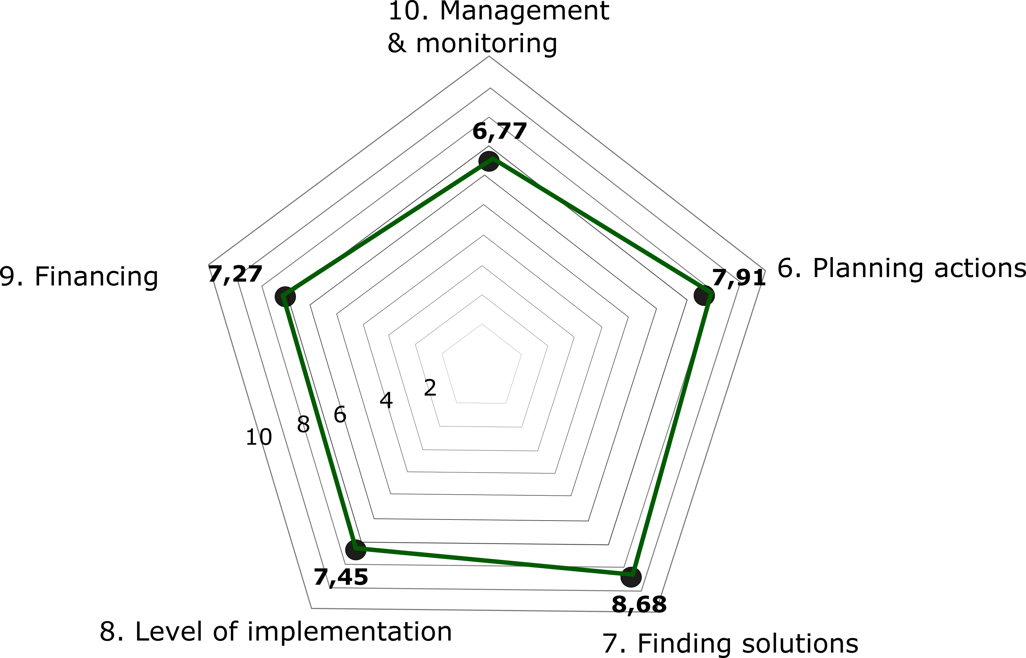

- It is useful to plan next steps: Based on the outcomes of the monitoring results, next steps might be planned, including discussion with the rural community about the results, planning improvements in the weaker aspects, etc.

Annex I: Monitoring reporting template for “monitoring experts”
Name of village: | [Name of village] | Country: | [Name of country]
Date of reporting: | DD/MM/YYYY

Overall assessment:
[Max. 250 words]

List of local interviewees
Name(s) of lead village contact(s) consulted: | Role | Date of interview/ discussion
Person 1:
Person 2:
…
Names of interviewees (non-lead local inhabitants) - [2-5 interviewees]
Person 1:
Person 2:
…

Milestone | Criteria | Assessment/ justification  (Short 1 or 2 paragraph assessments – responses to key questions - to justify and evidence scoring, could be numbered according to questions for easier tracking) | Indicative scoring of criteria (optional) | Overall scoring of milestone
1. Getting started | 1.1. Local governance capacity
 | 1.2 Leadership & vision
 | 1.3 Local stakeholder capacity
2. Mapping context and stakeholders | 2.1 Baseline analysis & mapping
 | 2.2 Stakeholder needs assessment
3. Engaging stakeholders | 3.1 Consultations
 | 3.2 Participatory planning
4. Designing strategy | 4.1 Existing strategies, strategic documents or plans
 | 4.2 Existing flagship projects or innovative ideas
 | 4.3 Assets, strengths, opportunities
 | 4.4 Challenges/ weaknesses, needs, threats
 | 4.5 Participatory methods in design
 | 4.6 Integration with other strategies
5. Smart Village Strategy | 5.1 Contents, structure & logic

6. Planning actions | 6.1. Comprehensive action plans
 | 6.2 Community engagement
7. Finding solutions | 7.1 Innovative smart solutions in response to needs
 | - Engaging community in finding actions
8. Implementing actions | - Level of implementation of planned actions
 | - Engaging community in implementing actions
9. Financing | 9.1 Identification of financing for solutions
 | 9.2 Use of financing
10. Management & monitoring | 10.1 Effective framework and implementation of management & monitoring of SV strategy

Annex II: Spiderweb visualisation of results - Templates

Strategy design

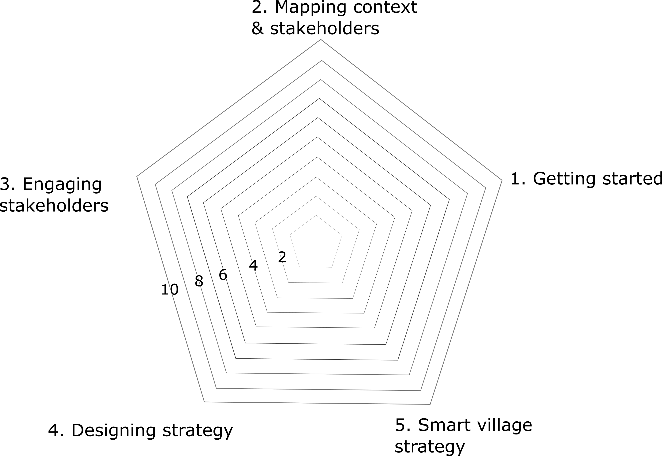

Strategy implementation

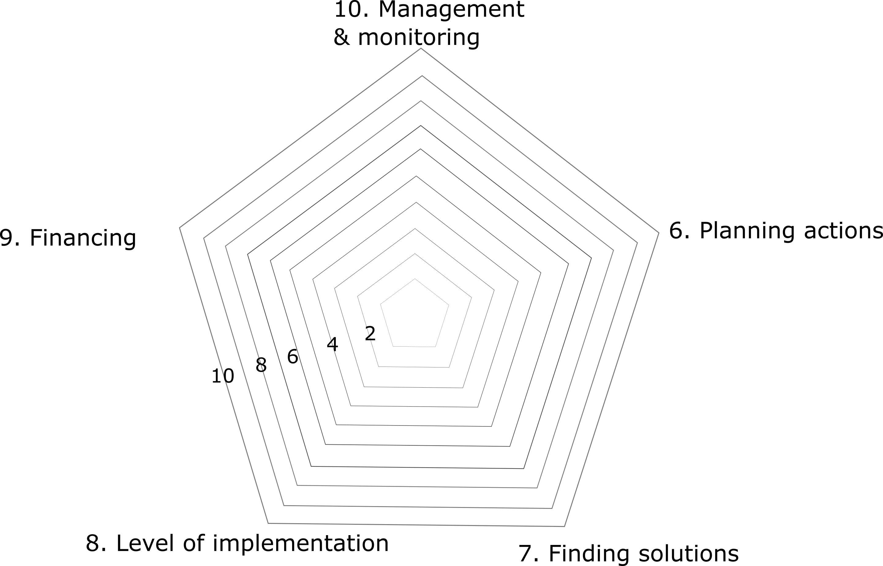

The Smart Rural 21 project also provided specific methods and tools as guidance for the implementation of these steps in the Roadmap Toolbox.

